Modeling and simulation of marine propeller

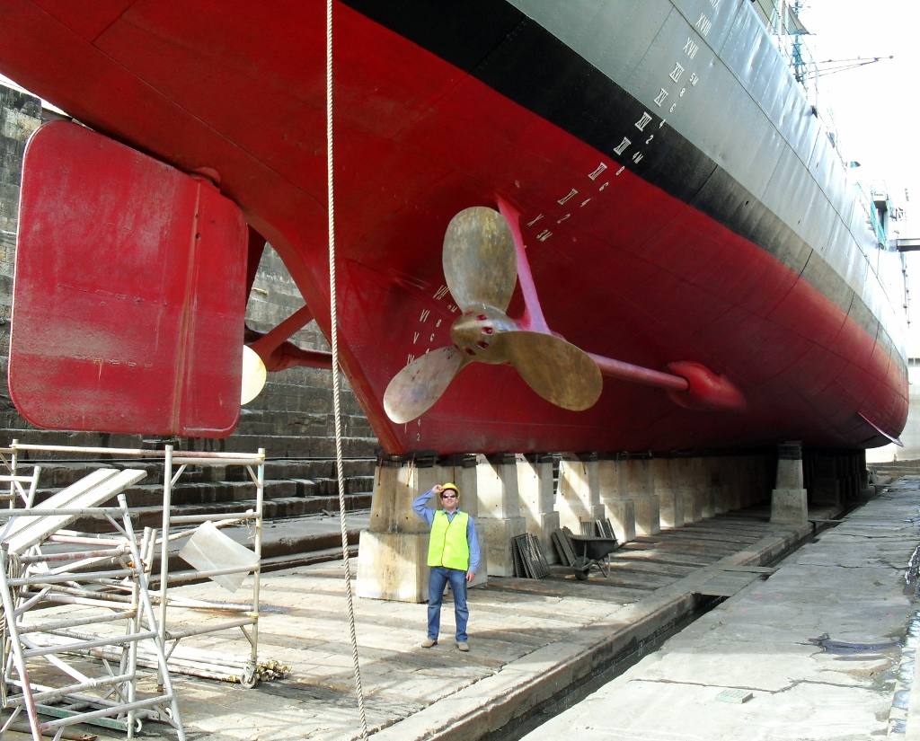
ABSTRACT
A propeller is a type of fan that transmits power by converting rotational motion into thrust. A pressure difference is produced between the forward and rear surfaces of the airfoil-shaped blade, and a fluid (such as air or water) is accelerated behind the blade. Propeller dynamics can be modeled by both Bernoulli's principle and Newton's third law. A marine propeller is sometimes colloquially known as a screw propeller or screw.
The present work is directed towards the study of marine propeller working and its terminology, simulation and flow simulation of marine propeller has been performed .The von misses stresses, resultant deformation , strain and areas below factor of safety has been displayed.
The velocity and pressure with which the propeller blades pushes the water has been displayed in the results.
By using solid works software we done modeling and simulation on marine propeller

